**C Notes**

1. **Separate Even/odd number from an array**

#include<stdio.h>

int main()

{

int arr[]={1,5,7,6,4,5};

int size;

size=sizeof(arr)/sizeof(int);

printf("Even number-->");

for(int i=0;i<size;i++)

{

if(arr[i]%2==0)

{

printf("%d ",arr[i]);

}

}

printf("\nOdd number-->");

for(int i=0;i<size;i++)

{

if(arr[i]%2!=0)

{

printf("%d ",arr[i]);

}}

return 0;

}

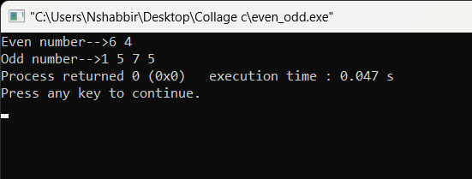

**Q2. Insert an element in the array in the given position.**

#include<Stdio.h>

int main()

{

int arr[40];

int size,index,num;

printf("Enter the size of Array:");

scanf("%d",&size);

printf("Enter the elelmnt of the array:");

for(int i=0;i<size;i++)

scanf("%d",&arr[i]);

printf("\nEnter the index number Which you want to add new elelment :");

scanf("%d",&index);

printf("Enter the number:\n");

scanf("%d",&num);

for(int i=size-1;i>=index;i--)

{

arr[i+1]=arr[i];

}

arr[index]=num;

for(int i=0;i<=size;i++)

printf("%d ",arr[i]);

return 0;

}

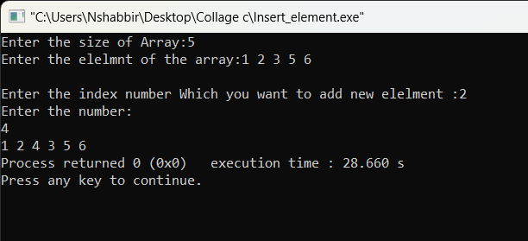

Q3.Delete an element from the array from the given position.

#include<Stdio.h>

int main()

{

int arr[40];

int size,index,num;

printf("Enter the size of Array:");

scanf("%d",&size);

printf("Enter the element of the array:\n");

for(int i=0;i<size;i++)

scanf("%d",&arr[i]);

printf("\nEnter the index number Which you want to delete element :");

scanf("%d",&index);

for(int i=index;i<size-1;i++)

{

arr[i]=arr[i+1];

}

for(int i=0;i<size-1;i++)

printf("%d ",arr[i]);

return 0;

}

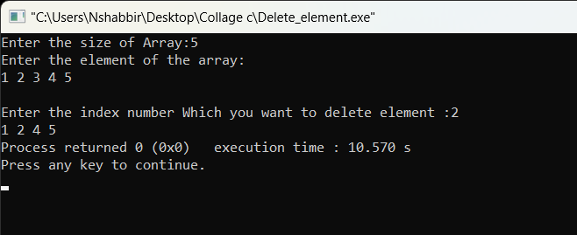

**Q4. Reverse the array.**

#include<stdio.h>

int main()

{

int arr[40];

int size,temp;

printf("Enter the size of Array:");

scanf("%d",&size);

printf("Enter the element of Array:\n");

for(int i=0;i<size;i++)

scanf("%d",&arr[i]);

for(int i=0;i<size/2;i++)

{

temp=arr[i];

arr[i]=arr[size-i-1];

arr[size-i-1]=temp;

}

for(int i=0;i<size;i++)

printf("%d ",arr[i]);

return 0;

}

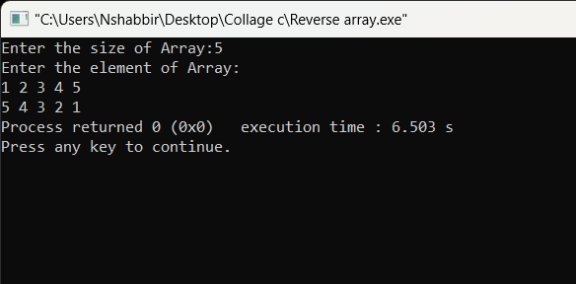

**Q5. Linear search**

#include<stdio.h>

int main()

{

int size,e,count=0;

printf("Enter the size of array:");

scanf("%d",&size);

int arr[size];

printf("Enter the element of array:\n");

for(int i=0;i<size;i++)

scanf("%d",&arr[i]);

printf("Enter the element you want to search:");

scanf("%d",&e);

for(int i=0;i<size;i++)

{

if(arr[i]==e)

{

printf("Element is found in %d position",i);

count++;

}

}

if(count==0)

printf("Element not found");

return 0;

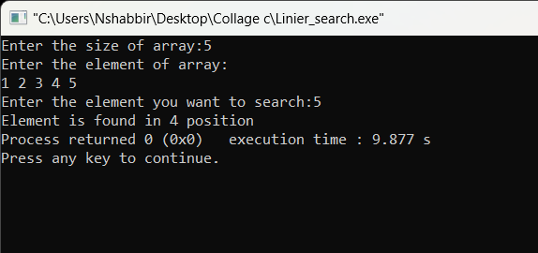}

**Q6. Binary Search**

#include<stdio.h>

int main()

{

int mid,i,key,size,beg,end;

printf("Enter the size of array:");

scanf("%d",&size);

int arr[size-1];

printf("Enter the element of array in shorted(ascending) order:\n");

for(i=0;i<size;i++)

scanf("%d",&arr[i]);

printf("Enter the element you want to search:");

scanf("%d",&key);

beg=0;

end=size-1;

while(beg<=end)

{

mid=(beg+end)/2;

if(arr[mid]==key)

{

printf("Element is found in position %d\n",mid);

for(int i=1;i<=mid;i++)

{

if(key==arr[mid-i])

{

printf("Element is found in position %d\n",mid-i);

}

else

break;

}

for(int i=1;i<=mid;i++)

{

if(key==arr[mid+i])

{

printf("Element is found in position %d\n",mid+i);

}

else

break;

}

break;

}

if(key<=arr[mid])

{

end=mid-1;

}

if(key>arr[mid])

{

beg=mid+1;

}

}

if(end<beg)

printf("Element is not found");

return 0;

}

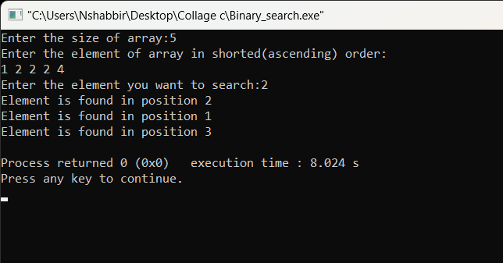

**Q7. Bubble sort**

#include<stdio.h>

int main()

{

int size,temp;

printf("Enter the size of array");

scanf("%d",&size);

printf("Enter the element of the array:\n");

int arr[size];

for(int i=0;i<size;i++)

scanf("%d",&arr[i]);

for(int i=0;i<size-1;i++)

{

for(int j=0;j<size-1;j++)

{

if(arr[j]>arr[j+1])

{

temp=arr[j];

arr[j]=arr[j+1];

arr[j+1]=temp;

}

}

}

printf("Shorted array is:\n");

for(int i=0;i<size;i++)

printf("%d ",arr[i]);

}

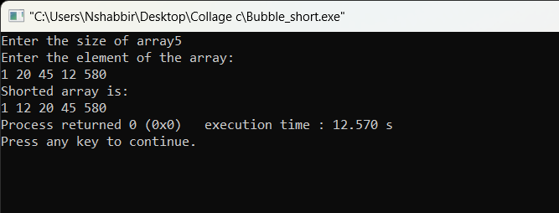

**Q8. Selection short**